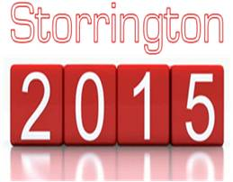
3RD OCTOBER 2015
ORDER OF EVENTS

2:30pm - Start of Bell Tournament
To follow - Mike Van der Weyden’s “Long Drop” event
Free personal training session with Kyle in the Gym.
Pool event organised by Joel.
Darts event organised by Ricky.
Raffle draw.
6:00pm - Hog Roast.
7:00pm - Presentation of Trophies.
8:00pm - Start of World cup rugby on television. England v Australia.
9:00pm - Music by “Billy Nomates”.

As always family and friends are invited to this event at the SSC.
