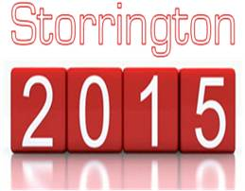
14th NOVEMBER 2015
ORDER OF EVENTS
1:00PM CLUB OPEN FOR INFORMAL EVENT
- MIKE VAN DER WEYDEN’S “LONG-DROP” EVENT
- DARTS EVENT
2:00PM TICKETY- BOO SEMI-FINALS ON 2 COURTS.
3:00PM CUP SEMI-FINALS ON 2 COURTS
4:00PM LONG DROP COMPETITION
- POOL & DARTS EVENTS
- TEA, COFFEE & CAKES
5:00PM TICKETY-BOO FINAL ON 1 COURT
6:00PM CUP FINAL ON 1 COURT
7:00PM FOOD SERVED ALL EVENING
7:30PM PRESENTATION OF TROPHIES
- AUCTION
8:00PM MUSIC BY “THE VOLTZ”
- INTERVAL RAFFLE DRAW
9:30PM FOLLOW WITH MUSIC
AS ALWAYS FAMILY AND FRIENDS ARE INVITED TO THIS EVENT.

